Corresponding Angles

Both lie above or below parallel lines, on the same side of the transversal.
EQUAL.
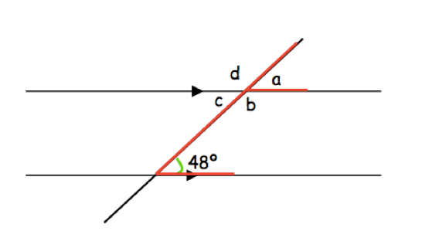

Which angle is corresponding to 48 degrees?

Colour both angles so they are easy to identify.

What is the angle’s value? ____

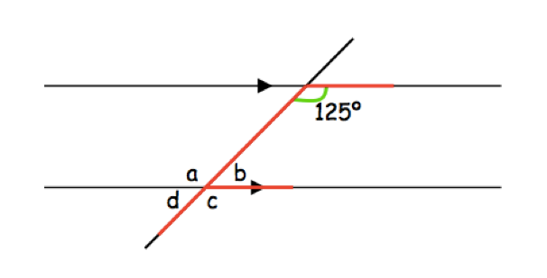
Which angle is corresponding to 125 degrees?

Colour both angles so they are easy to identify.

What is the angle’s value? ____

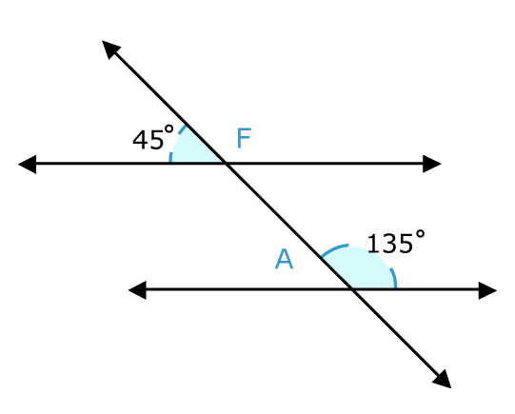

Find a and f using your knowledge of angles.

A =

F =

Use four different colours to circle/colour the pairs of corresponding angles.

